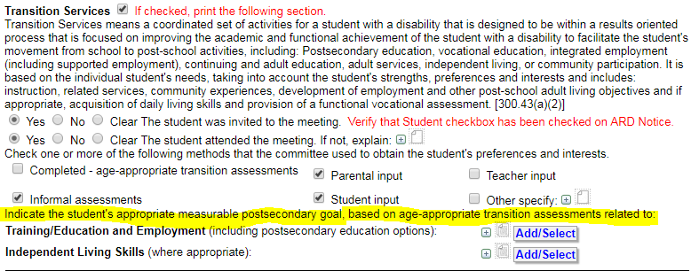

**Training Education and Employment**

Upon graduating from high school, [student’s name] will [do what, where, and how]

*Example: Upon graduating from high school, Joe will attend a career training program for welding at a local community college with support from the 18+ program teacher at KIPP Austin Collegiate.*

**Independent Living Skills**

Upon graduating from high school, [student’s name] will [do what, where, and how]

*Example: Upon graduating from high school, Joe will independently use public transportation to travel in the community for school, work, etc.*

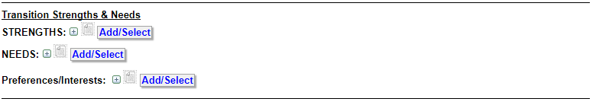

**STRENGTHS:**

All stakeholders should collaborate on what the student’s strengths are. Research shows that student-centered language results in better post-school outcomes.

For students who are able to present in their transition plan, this also facilitates a script so they can present their plan. If a student is not able to attend their meeting for some reason, the results of transition surveys, interview or survey data should be shared from the student’s perspective.

Here is a framework for how to document in transition plan:

[Student] noted the following as strengths on (his/her transition assessment or as recorded in a student interview)

Parents noted the following strengths of their child (reported by interview, parent survey, in meeting)

Teachers/Staff note strengths of [student] (data captured through observation, interview, and transition assessment survey)

*Example:*

*Joe noted his strengths are playing baseball, attending tutorials at lunch to make sure he completes assignments, and being helpful to his classmates in an interview prior to his transition meeting. On an informal assessment from Unique, Joe also recorded the following strengths: organized, friendly, outgoing, athletic.*

*Joe’s mother reported in a phone interview prior to his transition meeting that at home he always completes his chores without being asked, he completes his homework as soon as he gets home, and he helps out with his younger siblings.*

*Joe’s teachers note that he is always willing to help a classmate, regularly takes ownership for his learning by attending tutorials during lunch, and is a skilled pitcher on the baseball team. Data collected through google forms for teachers who were not present in meeting and through observational reports.*

**NEEDS:**

This information will come through a variety of sources but should be grounded in the student’s post-secondary goals and for high school/18+ from the Transition Assessment Planning Form.

*[Student] needs support in the following areas as assessed by an informal assessment inventory: [insert skills]*

*Parents report that [student] needs support with the following [insert skills] as identified through (interview, parent transition planning inventory, observation, etc)*

*Teachers note [student] needs support with the following [insert skills] as identified through (observation, data collection, survey, checklist)*

*The committee agrees that in the 20xx-20xx school year, [student] will work on developing the following skills to make progress toward post-secondary goals. (this will become the basis for your annual transition related goals)*

**Preferences/Interests:**

This is all student identified! There should not be any information from other stakeholders except if the student is not able to identify their preferences and interests. Multiple modes of identifying strengths and interests should be used to allow students to express this: symbol based, verbally identify, observe and confirm with student with yes/no about whether they like or do not like certain things.

*[Student] indicated preferences and interests in [list what preferences and interests are].*

Examples:

Higher functioning:

Joe noted that he prefers a job that is hands-on. On the Reading Free Interest Inventory, he strongly identified with hands on careers. After viewing career videos, Joe identified an interest in welding.

Joe also enjoys athletic activities and is outgoing. He is interested on continuing to play baseball in high school and after high school.

Joe indicated on an independent living assessment from UNIQUE that he would like to live in an apartment with a roommate after securing a job once he completes his job training program for welding.

Moderate-Severe Needs:

Sally is interested in looking at books, watching preferred shows such as Sponge Bob and Super Why, listening to upbeat music and is drawn to things with lots of colors or novel sounds. She shows interest in familiar adults and peers by smiling and laughing when they are near. She shows when she is not interested in something through facial gestures or looking away. Data was collected through observation, parent reports and teacher reports, as well as data collected through binary assessment with visual choices.

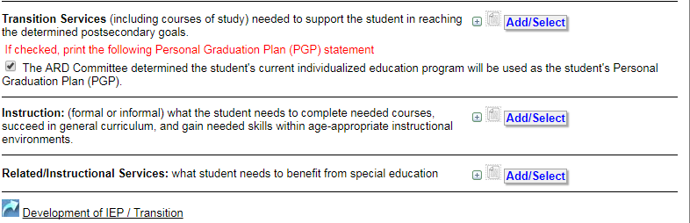

**Transition Services:**

*Middle School*

[Student] will be transitioning from [middle school campus] to KIPP Austin Collegiate for 20xx-20xx school year.

*High School/18+*

[Student] will participate in the GAIN program at KIPP Austin Collegiate in order to make progress towards transition related IEP goals in the areas of [list areas-vocational skills, post-secondary education/training, activities of daily living, independent living]. The committee reviewed the student’s graduation plan and determined the student will complete coursework to earn [choose one: foundation’s high school plan or foundations high school plan with endorsements]. 18+ programming was discussed and the committee anticipates the student will/will not participate in 18+ programming.

**Instruction:**

[Student] will take the following courses in an inclusion setting with modified coursework and accommodations. He/She will take the following courses in GAIN [list GAIN courses]. [Student] will participate in GAIN 101/201/301 to develop [prevocational skills, social skills, independent living skills, post-secondary education] *OR* [Student] will take Junior/Senior seminar in order to prepare for post-secondary education.

**Related/Instructional Services:**

[Student] receives the following services [speech, ABA, VI, PT, OT, nurse] to support progress towards post-secondary goals.

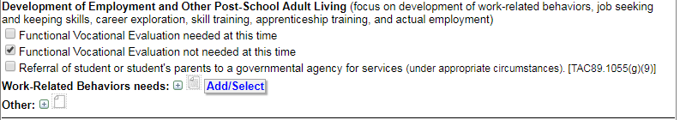

**Work-Related Behavior needs:**

*Middle School*

[Student] participates in an on campus job [insert on campus job and brief description] and has developed the following skills [list skills] determined through data collection and observation by staff [daily, weekly, monthly, quarterly].

[Student] indicated an interest in working in the field of [insert career interest]. Skills the student will need to develop are [list skills] as determined by observing the student, parent interview, transition survey, staff report.

*High school*

[Student] participates in an on campus job/off campus job [insert on campus job and brief description] and has developed the following skills [list skills] determined through data collection and observation by staff [daily, weekly, monthly, quarterly]. [Student’s] Transition Assessment Planning Form indicates the following areas of need [list areas of need from career section and post-secondary education and training if applicable]. Family also reported [student] needs support with as noted via interview, meeting deliberations, transition survey].

*18+*

[Student] is currently exploring careers through [job shadowing, volunteering, internship, paid job]. [Student] needs support to develop [list skills- transportation, schedule, staying on task, accepting feedback, etc] as documented through [environmental work assessment, student report, supervisor report, job coach report, vocational rehab counselor report, parent report, observation and data collection, Transition Assessment Planning Form]

OR

[Student] is currently working as a [paid worker, intern, volunteer] at [location]. Skills that need to be developed are [list any skills] as reported by [environmental work assessment, student report, supervisor report, job coach report, vocational rehab counselor report, parent report, observation and data collection, Transition Assessment Planning Form].

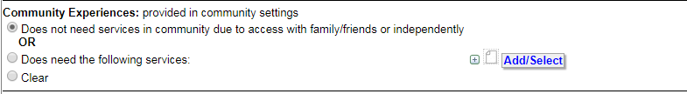



If needed make sure you uncheck the box!

List skills that the student needs to acquire to be as independent as possible.

Here are some potential skills but this list is not comprehensive:

Personal care-diapering, toileting, using feminine hygiene products, shaving, haircare, showering and wearing deodorant

ADLs: doing laundry, cleaning room, bathroom and common areas, preparing your own snack/meal, requesting a ride or taking the bus, going to the dentist or doctor, being able to write and/or communicate personally identifying information (address, phone number, DOB, guardianship status), reading time and following a schedule, using AT device or ASL to communicate with unfamiliar people in community.

Data sources for reporting: student report, parent report, teacher/staff report, observation, Transition Assessment Planning Form

